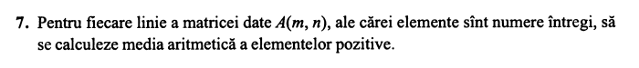

#include<iostream>

using namespace std;

main(){

int a[20][30], i, j, m, n, s=0,c;

cout<<"Dati numarul de linii m=";

cin>>m;

cout<<"Dati numarul de coloane n=";

cin>>n;

for(i=0; i<=m-1; i++)

for(j=0; j<=n-1; j++){

cout<<"a["<<i+1<<"]["<<j+1<<"]=";

cin>>a[i][j];

if(a[i][j]>0)

s+=a[i][j];

}

for(i=0; i<=m-1; i++)

for(j=0; j<=n-1; j++){

c++;

}

cout<<"Matricea introdusa: "<<endl;

for(i=0;i<n;i++){

for(j=0;j<m;j++)

cout<<a[i][j]<<" ";

cout<<endl;

}

cout<<"Media aritmetica este egala cu "<< (float) s/c;

}

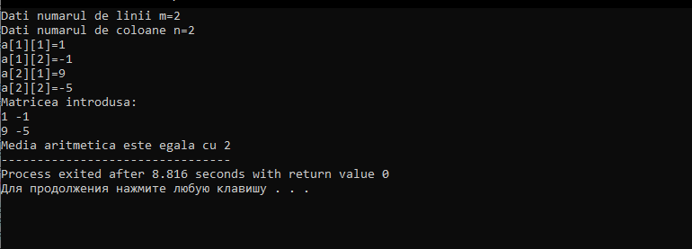

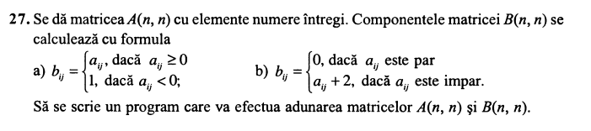

#include <iostream>

using namespace std;

main(){

int n,i,j,a[30][30],b[30][30],c[30][30];

cout<<"Dati dimensiunile matricii patratice"<<endl;

cout<<"Dati n : ";cin>>n;

for(i=0;i<n;i++)

for(j=0;j<n;j++){

cout<<"a["<<i+1<<","<<j+1<<"]= ";

cin>>a[i][j];

}

cout<<"----------------------"<<endl;

cout<<"Elementele matricii A sunt: "<<endl;

for(i=0;i<n;i++){

for(j=0;j<n;j++)

cout<<a[i][j]<<" ";

cout<<endl;

}

cout<<"----------------------"<<endl;

for(i=0;i<n;i++)

for(j=0;j<n;j++){

if (a[i][j]>=0){b[i][j]=a[i][j];

}else if (a[i][j]<0){

b[i][j]=1; }}

cout<<"Elementele matricii B sunt: "<<endl;

for(i=0;i<n;i++){

for(j=0;j<n;j++)

cout<<b[i][j]<<" ";

cout<<endl;

}

cout<<"----------------------"<<endl;

cout<<"A + B = "<<endl;

for(i=0;i<n;i++){

for(j=0;j<n;j++){

c[i][j]=a[i][j]+b[i][j];

}}

for(i=0;i<n;i++){

for(j=0;j<n;j++)

cout<<c[i][j]<<" ";

cout<<endl;

}

return 0;

}

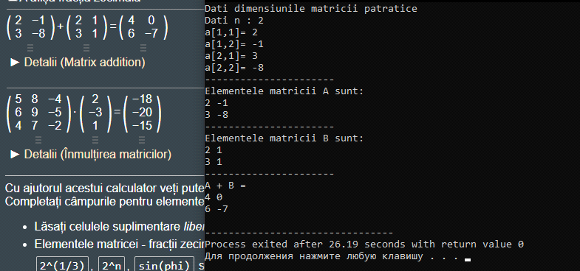

b)

#include <iostream>

using namespace std;

main(){

int n,i,j,a[30][30],b[30][30],c[30][30];

cout<<"Dati dimensiunile matricii patratice"<<endl;

cout<<"Dati n : ";cin>>n;

for(i=0;i<n;i++)

for(j=0;j<n;j++){

cout<<"a["<<i+1<<","<<j+1<<"]= ";

cin>>a[i][j];

}

cout<<"----------------------"<<endl;

cout<<"Elementele matricii A sunt: "<<endl;

for(i=0;i<n;i++){

for(j=0;j<n;j++)

cout<<a[i][j]<<" ";

cout<<endl;

}

cout<<"----------------------"<<endl;

for(i=0;i<n;i++)

for(j=0;j<n;j++){

if (a[i][j]%2==0){b[i][j]=0;

}else if (a[i][j]%2!=0){

b[i][j]=a[i][j]+2; }}

cout<<"Elementele matricii B sunt: "<<endl;

for(i=0;i<n;i++){

for(j=0;j<n;j++)

cout<<b[i][j]<<" ";

cout<<endl;

}

cout<<"----------------------"<<endl;

cout<<"A + B = "<<endl;

for(i=0;i<n;i++){

for(j=0;j<n;j++){

c[i][j]=a[i][j]+b[i][j];

}}

for(i=0;i<n;i++){

for(j=0;j<n;j++)

cout<<c[i][j]<<" ";

cout<<endl;

}

return 0;

}

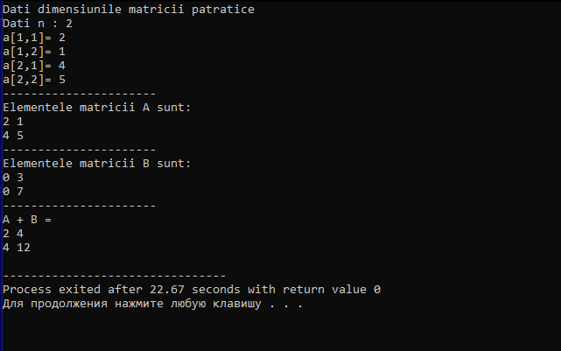

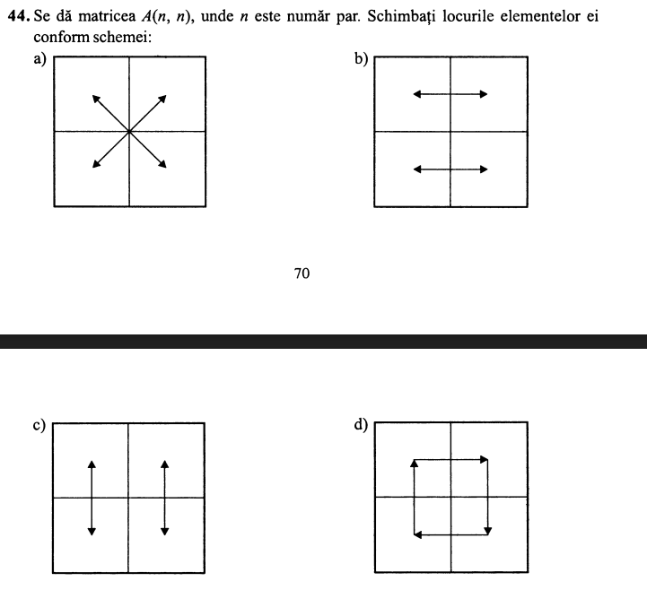

a)

#include <iostream>

using namespace std;

int main(){

int n,i,j,a[30][30],k,v[30],t[30],b[30][30];

cout<<"Dati dimensiunile matricii patratice"<<endl;

cout<<"Dati n : ";cin>>n;

for(i=0;i<n;i++)

for(j=0;j<n;j++){

cout<<"a["<<i+1<<","<<j+1<<"]= ";

cin>>a[i][j];

}

cout<<"----------------------"<<endl;

cout<<"Elementele matricii sunt: "<<endl;

for(i=0;i<n;i++){

for(j=0;j<n;j++)

cout<<a[i][j]<<" ";

cout<<endl;

}

cout<<"----------------------"<<endl;

for(i=0;i<n;i++)

for(j=0;j<n;j++)

if ((i < n/2 )&&(j < n/2)){

b[i + (n/2)][j + (n/2)] = a[i][j];

}

else if ((i >= n/2 )&& (j >= n/2)){

b[i - int(n/2)][j - int(n/2)] = a[i][j];

}

else if (i >= n/2 >= j){

b[i - int(n/2)][j + int(n/2)] = a[i][j];

}

else if (i <= n/2 <= j){

b[i + int(n/2)][j - int(n/2)] = a[i][j] ;

}

cout<<"Elementele matricii obtinute in varianta a) sunt: "<<endl;

for(i=0;i<n;i++){

for(j=0;j<n;j++)

cout<<b[i][j]<<" ";

cout<<endl;

}

return 0;

}

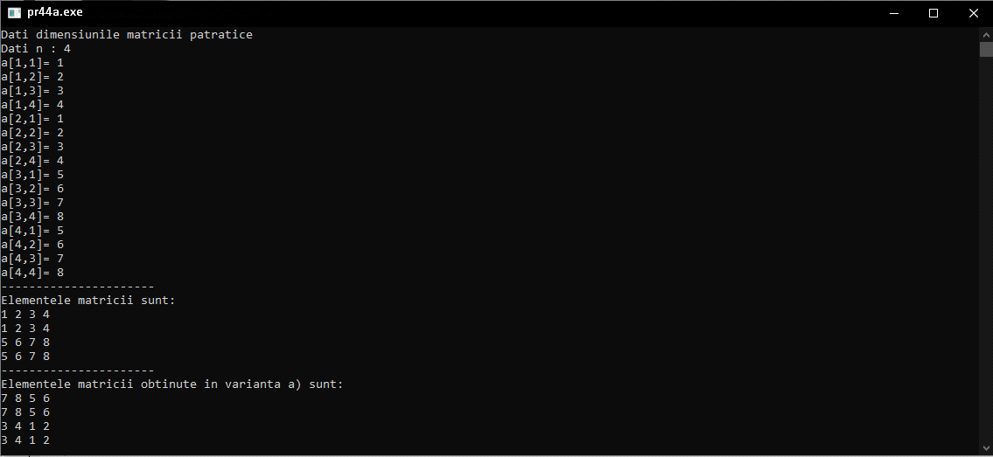

b)

#include <iostream>

using namespace std;

int main(){

int n,i,j,a[30][30],k,v[30],t[30],b[30][30];

cout<<"Dati dimensiunile matricii patratice"<<endl;

cout<<"Dati n : ";cin>>n;

for(i=0;i<n;i++)

for(j=0;j<n;j++){

cout<<"a["<<i+1<<","<<j+1<<"]= ";

cin>>a[i][j];

}

cout<<"----------------------"<<endl;

cout<<"Elementele matricii sunt: "<<endl;

for(i=0;i<n;i++){

for(j=0;j<n;j++)

cout<<a[i][j]<<" ";

cout<<endl;

}

cout<<"----------------------"<<endl;

for(i=0;i<n;i++)

for(j=0;j<n;j++)

if ((i < n/2 )&&(j < n/2)){

b[i][j] = a[i ][j + (n/2)];//cadranul 1 cu cadranul2

}

else if ((i >= n/2 )&& (j >= n/2)){

b[i-(n/2)][j] = a[i-(n/2)][j-(n/2)] ; //cadranul 2 cu cadranul 1

}

else if (i >= n/2 >= j){

b[i][j] = a[i][j + (n/2)] ;//cadranul 3 cu cadranul 4

}

else if ((i <= n/2 <= j)){

b[i+(n/2)][j] = a[i+(n/2)][j-(n/2)] ;//cadranul 4 cu cadranul 3

}

cout<<"Elementele matricii obtinute in varianta b) sunt: "<<endl;

for(i=0;i<n;i++){

for(j=0;j<n;j++)

cout<<b[i][j]<<" ";

cout<<endl;

}

return 0;

}

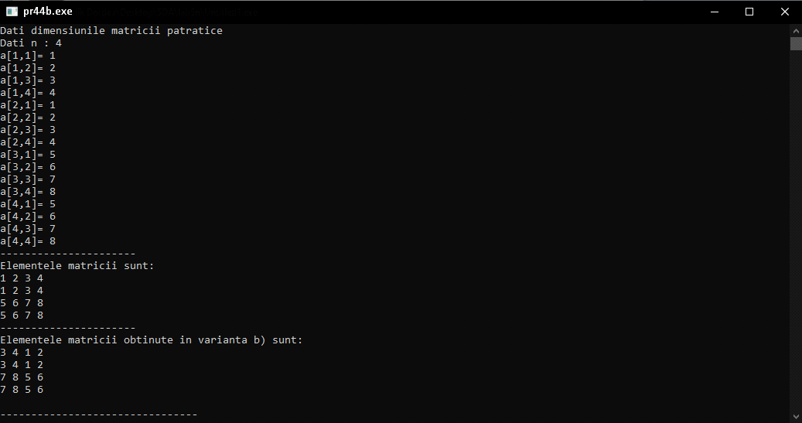

c)

#include <iostream>

using namespace std;

int main(){

int n,i,j,a[30][30],k,v[30],t[30],b[30][30];

cout<<"Dati dimensiunile matricii patratice"<<endl;

cout<<"Dati n : ";cin>>n;

for(i=0;i<n;i++)

for(j=0;j<n;j++){

cout<<"a["<<i+1<<","<<j+1<<"]= ";

cin>>a[i][j];

}

cout<<"----------------------"<<endl;

cout<<"Elementele matricii sunt: "<<endl;

for(i=0;i<n;i++){

for(j=0;j<n;j++)

cout<<a[i][j]<<" ";

cout<<endl;

}

cout<<"----------------------"<<endl;

for(i=0;i<n;i++)

for(j=0;j<n;j++)

if ((i < n/2 )&&(j < n/2)){

b[i][j] = a[i+ (n/2) ][j];//cadranul 1 cu cadranul 3

}

else if (i >= n/2 >= j){

b[i][j] = a[i-(n/2)][j] ;//cadranul 3 cu cadranul 1

}

else if ((i >= n/2 )&& (j >= n/2)){

b[i-(n/2)][j] = a[i][j] ; //cadranul 2 cu cadranul 4

}

else if ((i <= n/2 <= j)){

b[i+(n/2)][j] = a[i][j] ;//cadranul 4 cu cadranul 3

}

cout<<"Elementele matricii obtinute in varianta c) sunt: "<<endl;

for(i=0;i<n;i++){

for(j=0;j<n;j++)

cout<<b[i][j]<<" ";

cout<<endl;

}

return 0;

}

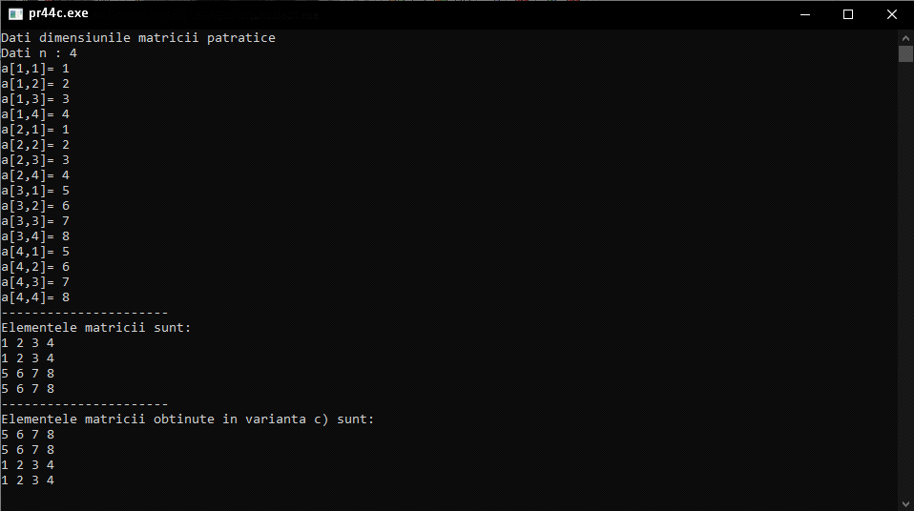

d)

#include <iostream>

using namespace std;

int main(){

int n,i,j,a[30][30],k,v[30],t[30],b[30][30];

cout<<"Dati dimensiunile matricii patratice"<<endl;

cout<<"Dati n : ";cin>>n;

for(i=0;i<n;i++)

for(j=0;j<n;j++){

cout<<"a["<<i+1<<","<<j+1<<"]= ";

cin>>a[i][j];

}

cout<<"----------------------"<<endl;

cout<<"Elementele matricii sunt: "<<endl;

for(i=0;i<n;i++){

for(j=0;j<n;j++)

cout<<a[i][j]<<" ";

cout<<endl;

}

cout<<"----------------------"<<endl;

for(i=0;i<n;i++)

for(j=0;j<n;j++){

if ((i >= n/2 )&& (j >= n/2)){

b[i-(n/2)][j] = a[i-(n/2)][j-(n/2)] ; //cadranul 2 cu cadranul 1

}

else if ((i <= n/2 <= j)){

b[i+(n/2)][j] = a[i][j] ;//cadranul 4 cu cadranul 2

}

if ((i < n/2 )&&(j < n/2)){

b[i+(n/2)][j] = a[i+(n/2)][j+(n/2)];//cadranul 3 cu cadranul 4

}

else if (i >= n/2 >= j){

b[i-(n/2)][j] = a[i][j] ;//cadranul 1 cu cadranul 3

}}

cout<<"Elementele matricii obtinute in varianta c) sunt: "<<endl;

for(i=0;i<n;i++){

for(j=0;j<n;j++)

cout<<b[i][j]<<" ";

cout<<endl;

}

return 0;

}

